Lesson 3 Demo 3: Maven Setup

This section will guide you to:

* Configure build tools and JDK versions

This lab has two sub-sections, namely:

1. Configuring the Maven setup
2. Configuring the JDK

**Step 1:** Configuring the Maven setup

* Open the terminal and go to **Jenkins dashboard** by typing **localhost:8081** in your browser
* Click on ***Manage Jenkins***. From the list of options, choose***Manage Plugins***.

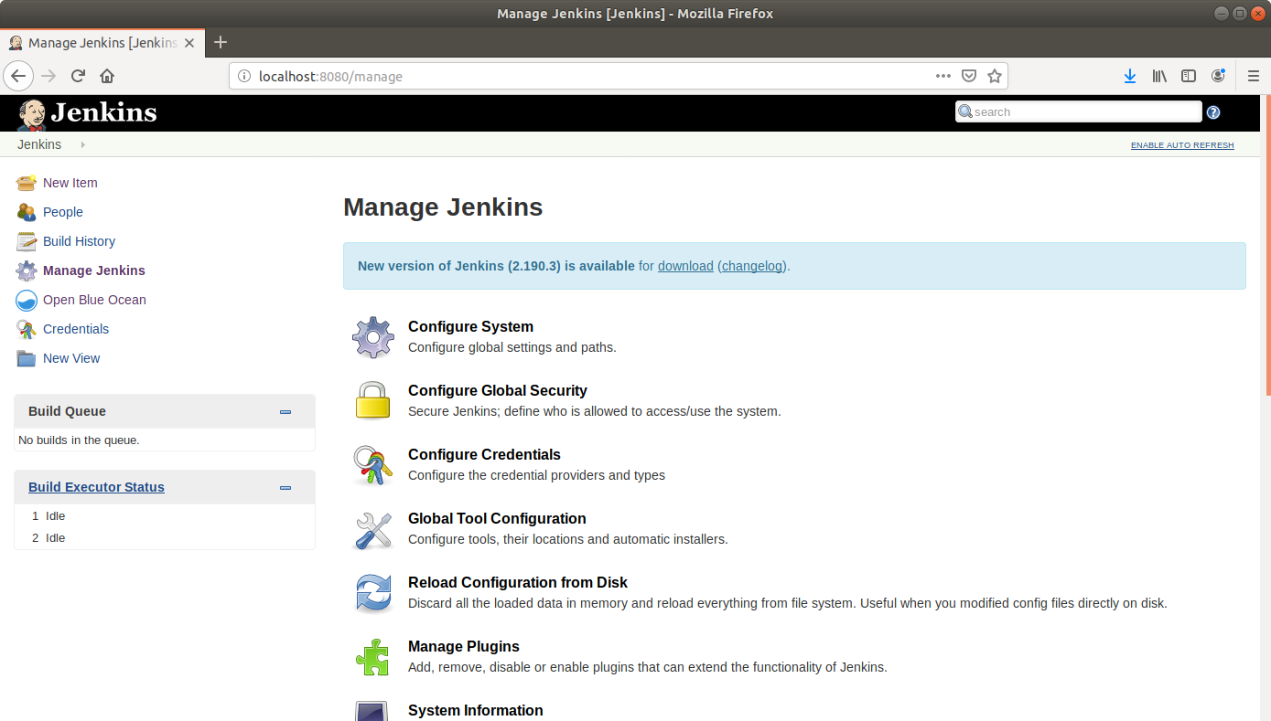

* Under the ***Available*** tab, select ***Maven Integration***

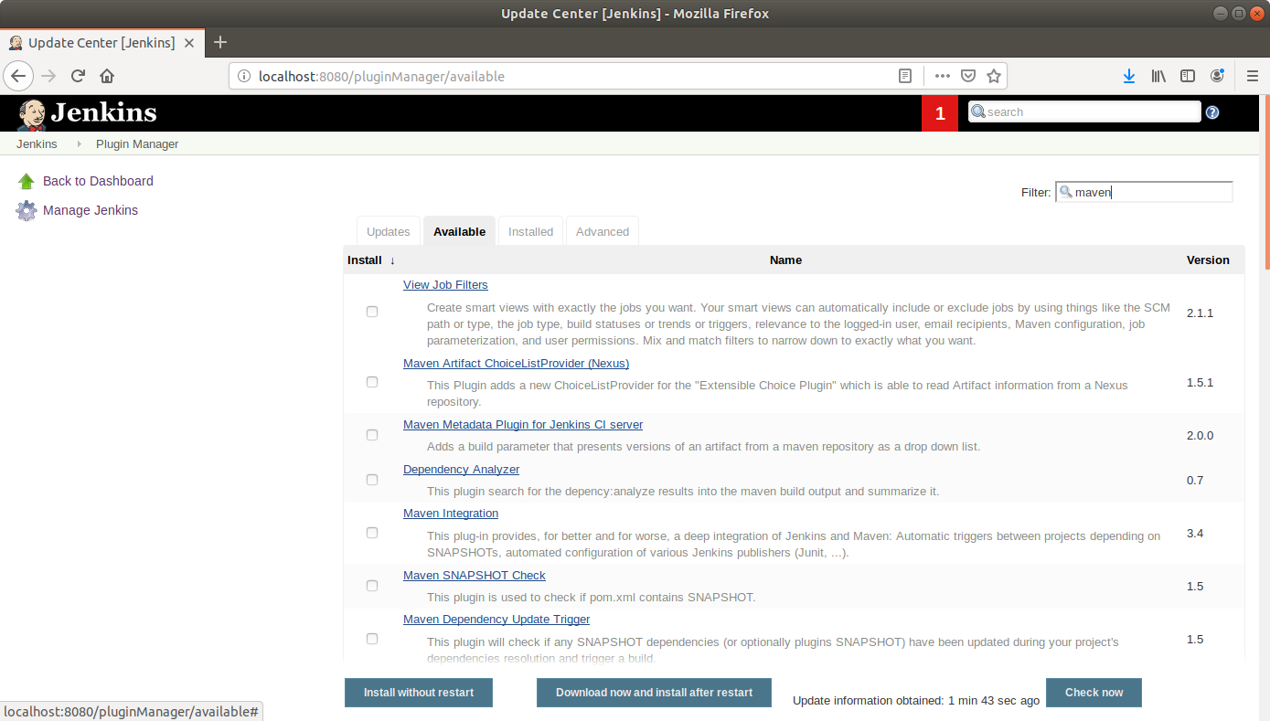

* Click on ***Install without restart*** and the plugin will be installed

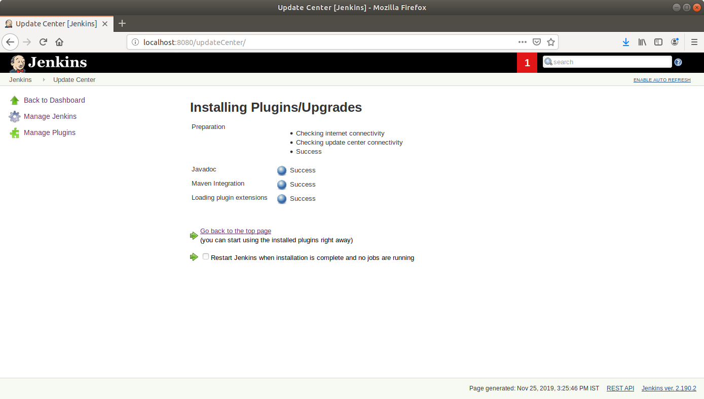

* Go to <https://maven.apache.org/download.cgi> and download the binary zip file

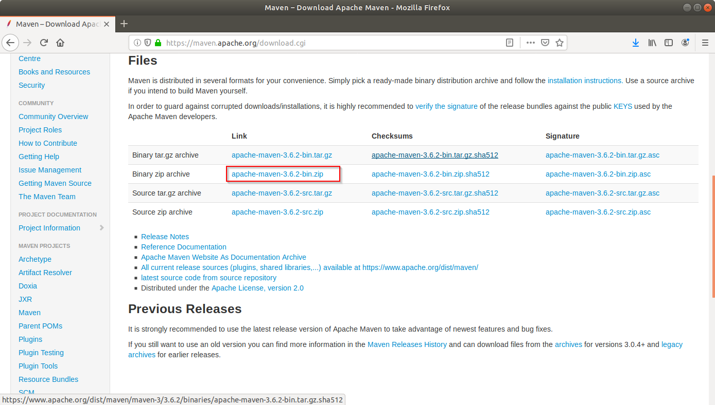

* Unzip and extract the file and copy the path.

**$ cd /home/labsuser/Downloads**

**$ unzip apache-maven-3.6.3-bin.zip**

* Go to ***Manage Jenkins*** from the Jenkins dashboard and select ***Global Tool Configuration***
* Scroll down to the ***Maven*** section and click on ***Add Maven***

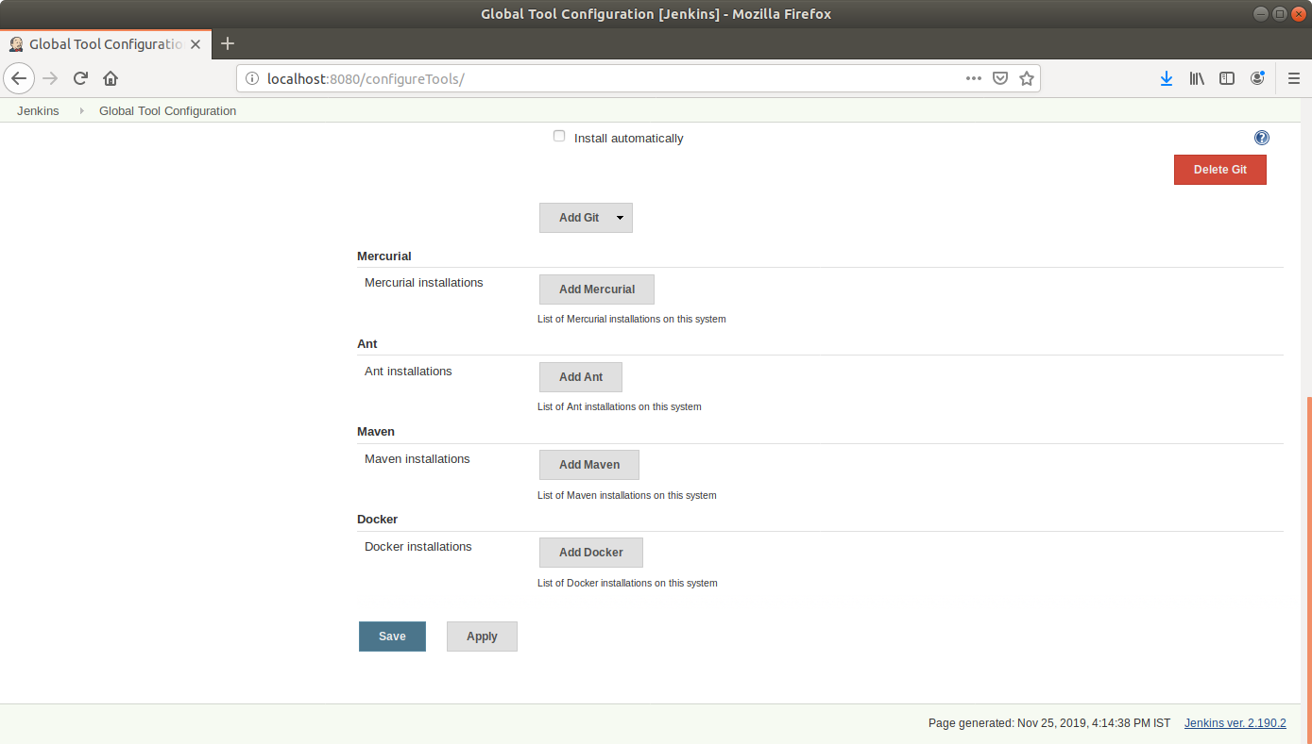

* You can choose to install automatically by ticking the checkbox and specifying the version, or uncheck the box and enter the local path if you want to configure manually.
* Enter a name for the installation (For Example: my_maven)
* Uncheck the ***Install* *automatically*** checkbox.
* Paste the path to the Maven file in the ***MAVEN_HOME*** field (**/home/labsuser/Downloads/apache-maven-3.6.3**) and click ***Save***

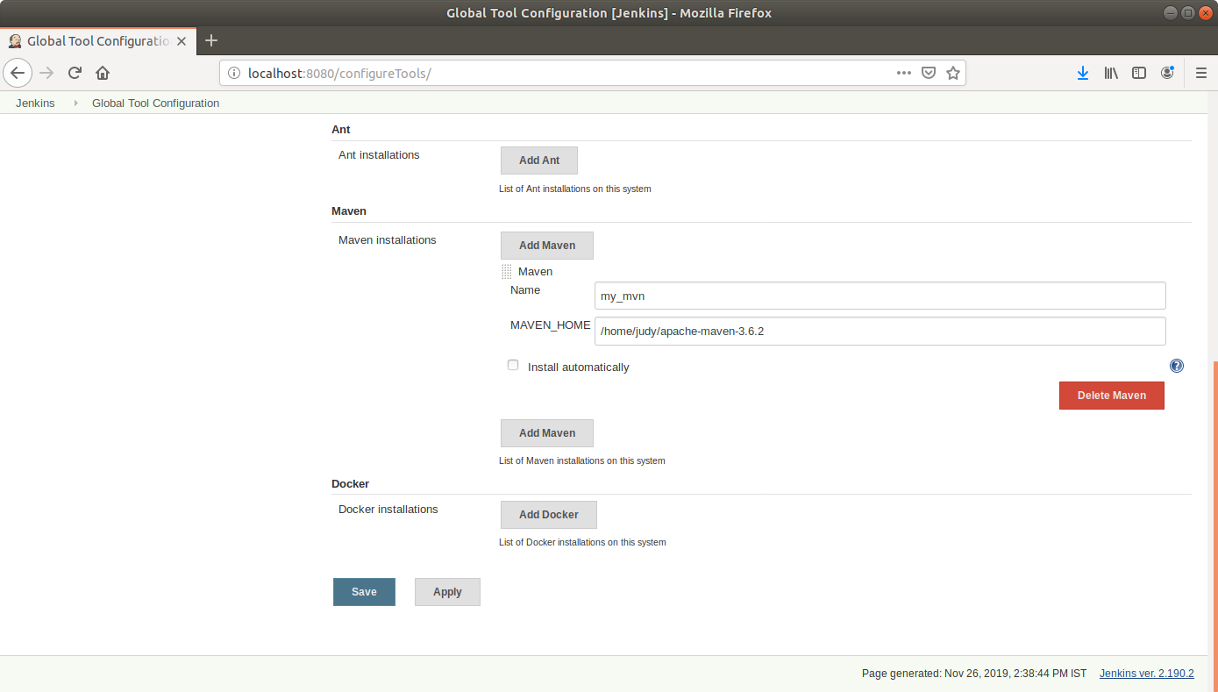

* You can now find ***Maven* *project*** as an option under ***New Item***.

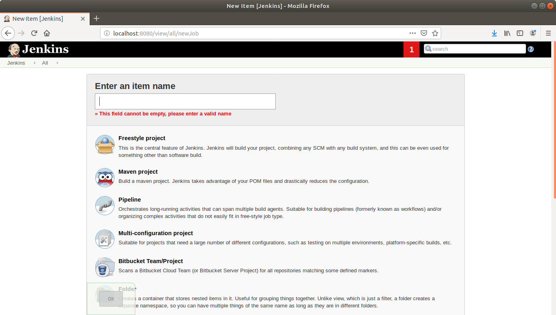

**Step 2:**  Configuring the JDK

* Go to ***Manage Jenkins*** from the Jenkins dashboard and select ***Global Tool Configuration***
* Scroll down to the ***JDK*** Section and click on ***Add JDK***

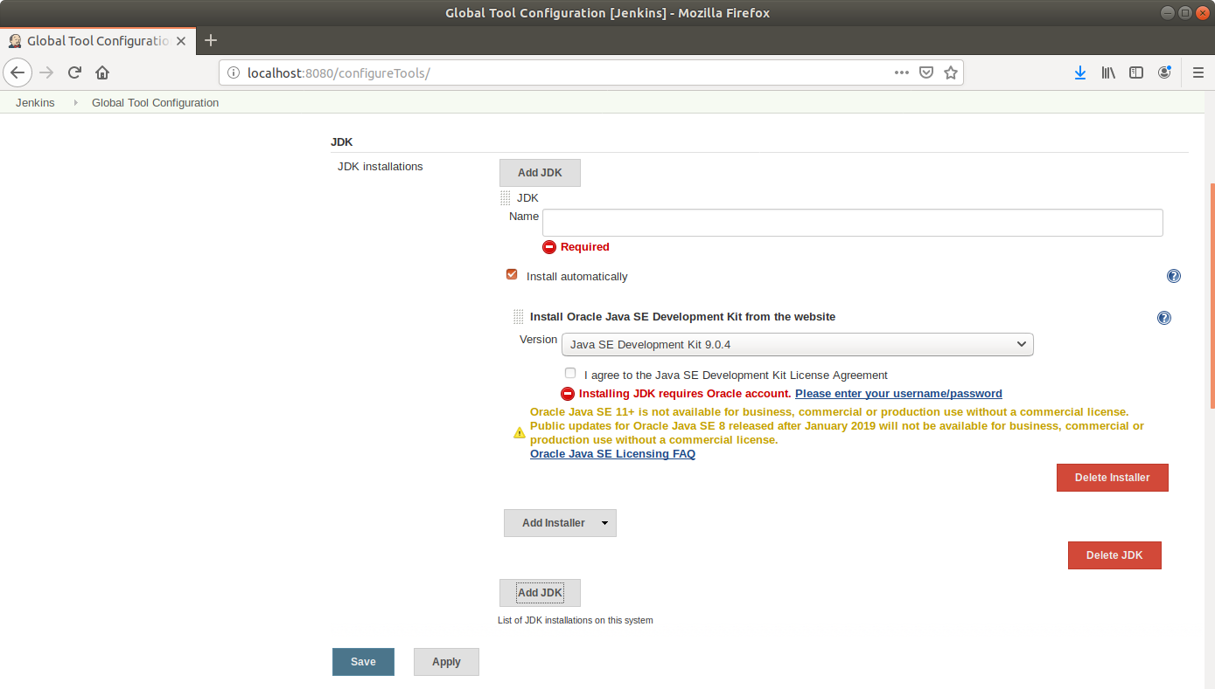

* You can choose to install automatically by ticking the checkbox and specifying the version. Uncheck the box if you want to enter the JDK path manually

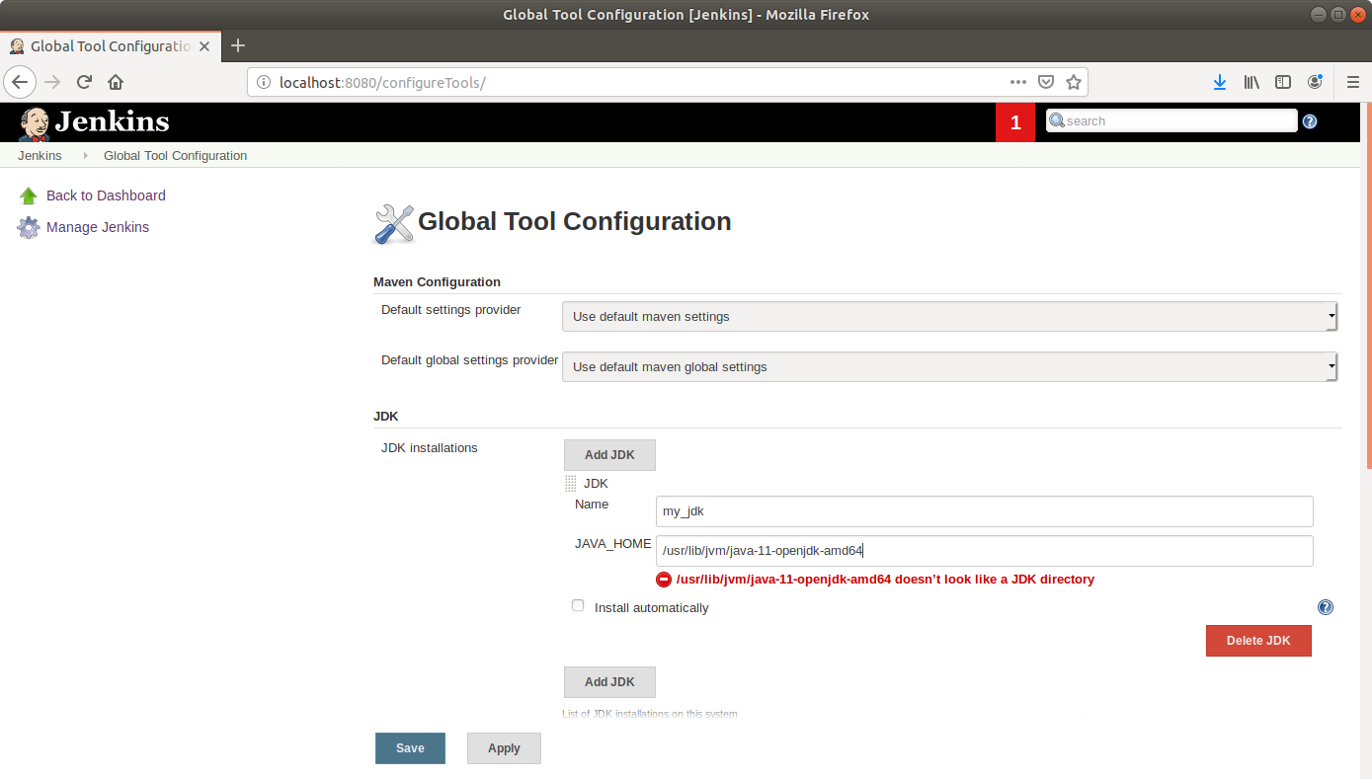

* Enter the path to the JDK in the **JAVA_HOME** field (**/usr/lib/jvm/java-8-openjdk-amd64/**) and click ***Save***